Introduction to linear algebra

我个人觉得，学习线性代数，最重要的不是去熟练矩阵运算和解方程的方法——这些在实际工作中MATLAB可以代劳，关键的是要深入理解几个基础而又重要的概念：**子空间(Subspace)，正交(Orthogonality)，特征值和特征向量(Eigenvalues and eigenvectors)，和线性变换(Linear transform)**。

Matrix viewed in row picture and in column picture

1. Row picture

2. column picture

$$\left[\begin{matrix}2 & 3 \\ 6 & 5\end{matrix}\right] \left[\begin{matrix}x \\ y\end{matrix}\right]= \left[\begin{matrix}0 \\ 3\end{matrix}\right]$$

$$x\left[\begin{matrix}2 \\ 6\end{matrix}\right]+y\left[\begin{matrix}3 \\ 5\end{matrix}\right]= \left[\begin{matrix}0 \\ 3\end{matrix}\right]$$

Linear combination of columns

Question: can I solve Ax=b for every b? do the linear combinations of the columns fill the plane? For this A, answer is Yes.

Matrix x Column = Column

Row x Matrix = Row

Matrix multiplication (4 ways)

AB=C

Columns of C are the combinations of columns of A

Rows of C are the combinations of rows of B

AB = sum of [(columns of A) * (rows of B)]

Blocks multiplication also works

Inverse matrix

If it exists, A-1A = AA-1 = I

A is invertible and non-singular

If A is singular, then it is not inverse

Reasons:

A matrix has no inverse if we can find a vector x so that Ax = 0. Then A-1Ax = 0, x = 0. But x! = 0.

In the column picture, the columns of matrix are in the same line, no filling the space

Gauss-Jordan (solve 2 equals at once)

Augment matrix: so that you can do the operations on both left and right hand side at once.

Why do we need A-1

E [ A I ] = [ I A-1 ], that is how we find inverse

Inverse of product (AB)

Factorization into A = LU

If no row exchanges, multipliers go directly into L

How many operations (multiplie + substract) on n x n matrix A?

12 + 22 + 32 + … + n2 = n3/3

How many operations (multiplie + substract) on n x n matrix b?

n2

Permutation matrix p

for 3 by 3, 6 p matrix. (3x2)

for 4 by 4, 24 matrix. (4x3x2), basically, it is n!

(AB)-1 = B-1A-1

PA = LU for any invertible A, which makes the row in good order where pivot is not o in the first place of the row

P-1 = PT

Transpose

4th dimension: 3d and duration (time and anti-time)

4th dimension is multiple “planck frames” of 3D space

The new dimension is somehow at right angles to the ones before

Time is not a dimension, it is a direction

Why we can not see the fifth dimension?

(AT)-1 = (A-1)T

RTR is always symmetric

Because (RTR)T = RTR

Space of vectors

To check if a matrix is symmetric or not? Take transpose

R2 = all 2 dimensional vectors

Algebra can act on vectors

Rn = vectors with n components

Subspace: eg. A line passing the point (0,0) in R2

Every subspace must have o inside.

Subspace of R2

1. All of R2
2. Any line through (0,0)
3. Zero vector only

Columns in R3

All their linear combinations form a subspace (in this case it is a plane), which is called column space C(A)

How do I understand Ax = b in the term of column space?

Me: if b is not in the subspace of A, then there is no answer.

Column space of A: solving Ax = b

Nullspace of A

Is the union of two subspaces a subspace?

No. why? Because the linear combination of columns may go outside of the union, that means the linear combination is not in the so called subspace.

Ax = b, where A is in 4 dimensions

4 equations but only 3 variables, so which b is allowed this system solved?

If b = 0, it solves, x = 0

If b = one of the columns of A,, it solves

If b is in the column space, it solves

Nullspace of A = all solutions to Ax = 0

Check that solutions to Ax = 0 always give a subspace

If Ax = 0, Aw = 0, then A (x + w) = 0

For Ax = b, the solutions form a subspace?

No. Because 0 does not satisfy it.

Question: for a matrix A: m x n, if m > n, how many answers to Ax = b?

A plane not going through (0) ?

If m < m, how many answers will be like?

Lecture 7

Compute the nullspace Ax = 0, nullspace

Pivot columns and free columns

For the free columns, we can assign any value to the corresponding x values

The rank of A = # of pivot columns, free variables = # of columns – rank (A)

Echelon form (upper triangle)

Special solutions --- rref(A) = R

Matrix R = reduced row echelon form (rref), zeros above + below pivots = 1

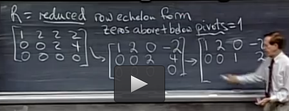

R tells me the pivot row and pivot column, and there’s indent matrix in the pivot rows and pivot columns

In matlab, it finds R, then pick out the I (pivot columns) and F (free columns)

Then set the value of x_free (generally it is I), then use F to find out x_pivot, which will be -F

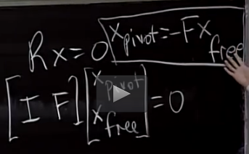

At last, do not forget the constant C in the very front of the answer.

Question: how can I know how many answers or not for Ax = 0?

Lecture 8

Solve Ax = b, row reduced form R

Is there a solution? Is it a single solution or a family?

Augmented matrix [ A b ]

Solvability condition on b:

Ax = b solvable when b is in C(A).

If a comb of rows of A gives zero row, then the same combination of entries of b must give 0.

To find complete sol’n to Ax = b

Step 1: a paticulat solution (X_paticular): set all free variables to zero. (free variables can be anything) Then solve Ax = b for pivot variables.

Step 2: back substation to check the particular solution

Step 3: complete solution: X = X_paticular + X_nullspace

A X_paticular = b

A X_nullspace = 0

A (X_paticular + X_nullspace) = b

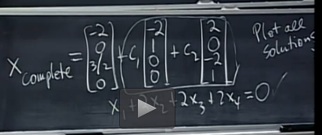

If A is m x n matrix, the rank is r, then r <= m, r <= n.

Full column rank means: r = n. What does that tell us about the complete solution? n pivot columns and 0 free variable, that means, in the null space, N(A) = zero vector only (Ax = 0). The solution x to Ax = b is a particular solution (only one) if the solution exists.

What is the rank? = how many pivots do you have?

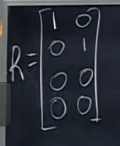

Full row rank means: r = m. What does that tell us about the complete solution? Can solve Ax = b for every b (existance).

How many free variables? n – r = n - m

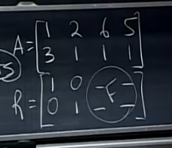

Case 3, When r = m =n, the matrix is square and full rank, it is invertible.

And R = I, null space is zero only. The solution x to Ax = b is a particular solution (only one).

table

|  |  |  |  |  |
| --- | --- | --- | --- | --- |
|  | r = n = m | r = n < m | r = m < n | r < m, r < n |
| Reduced matrix R | R = I | R = $\left[ \begin{matrix}I \\ 0\end{matrix} \right]$ | R = $\left[ \begin{matrix}I & F \end{matrix}\right]$ | R = $\left[\begin{matrix}I & F \\ 0 & 0\end{matrix}\right]$ |
| # of solutions to Ax = b | 1 (always soluble? Y) | 0 or 1 | Infinity | 0 or Infinity |

The rank tells everything about the solutions to Ax = b

Lecture 9

Linear independence

Spanning a space

Basis and dimension

Suppose A is m by n with m < n, then there are nonzero solutions to Ax = 0 (more unknown than equations)

Why? Because there are free variables.

Independence

Vectors x1, x2, x3, …, xn are independent if no combination gives zero vector (except the zero combination), that means, Ax = 0. Thus, these vectors are independent if the nullspace of A is zero only.

They are dependent if the nullspace of A is nonzero vectors.

Vectors s v1, v2, …, vl span a vector space means the space consists of all combinations of those vectors.

Basis for a vector space: a sequence of vectors in the space with two properties: 1st, they are independent; 2nd, they span the space.

Example:

Space is R3, one basis is (1,0,0), (0,1,0), (0,0,1)

For Rn, n vectors give basis if the n x n matrix with those col’s is invertible.

Question: when a n x n matrix is invertible, what does it mean? It means there is a solution to Ax = b?

If there is no solution to Ax = b, so A is not invertible. What are the n col’s in terms of basis? Are they not independent?

Given a space, every basis for the space has the same number of vectors, which is equal to the rank of space. The number is called the dimension.

Rank of matrix = # of pivot columns = dimension of the column space

What is the basis of the null space (null space is talking about the x)?

What is the dimension of the null space?

Why the solutions to Ax = 0 is the basis of the null space?

Dimension of N(A) is the # of the free variables = n – rank of A

Why?

How do we construct the nullspace (A)?

Elimination to find the reduced matrix R, then find a specific solution. Every specific solution is from a free variable.

Lecture 10

The four fundamental subspaces for matrix A (m x n)

Question: if the rows are dependent, then the columns are dependent? What is the connection between the column space and the row space?

1. The column space C(A) in Rm
2. The nullspace N(A) in Rn
3. The row space (A) = all combinations of rows, transpose the matrix, all combinations of columns of AT = C(AT) in Rn
4. The nullspce N(AT): the left null space of A in Rm

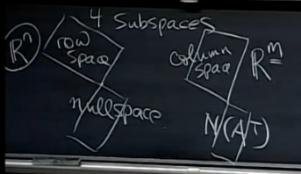

How to understand the spaces?

Basis?

Dimension?

table

|  |  |  |  |  |
| --- | --- | --- | --- | --- |
|  | C(A) | N(A) | C(AT) | N(AT) |
| Space | Rm |  | Rn |  |
| Basis | Pivot cols | Special solutions/ free cols |  |  |
| Dimension | Rank r | n - r | r | m - r |

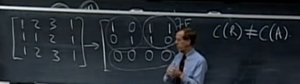

These row operations preserve the row space. Because the linear combinations of rows stay in the space. The column space of R is different from the column space of A. Though they have the same row spaces.

These operations preserve the rank of C(R) and C(A).

Question: why they are different? C(R) = 2 Instead of 3?

The basis of C(A) is

The basis of C(R) is

The basis of row space of (A) is first r rows of R, not of A. sometimes it is A, but not necessarily. why not A?

For the 4th space: N(AT)

ATy = 0

If we do the transpose, then, yTA = 0

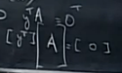

That is why it is called the left nullspace.

Go back to ATy = 0

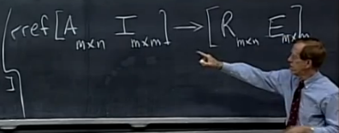

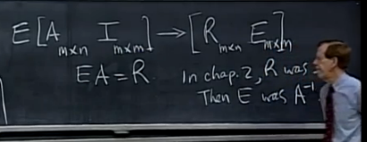

A new vector space M

All 3x3 matrices

Subspaces of M

Upper triangles

Symmetric matrices

Diagnol matrices

Lecture 11

Bases of new vector spaces

Rank one matrices

Small world graphs

M = all 3 by 3 matrices

Basis for M = all 3x3’s

The dimension is 9

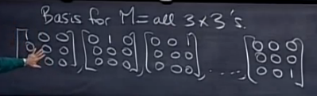

|  |  |  |  |  |  |
| --- | --- | --- | --- | --- | --- |
|  | all 3 by 3 matrices (M) | Upper triangles matrix (U) | Symmetric matrix (S) | Diagnol matrix (D = U $∩$ S) | U $∪$ S |
| Dimensions | 9 | 6 | 6 | 3 | 9 |

How do you how many vectors in a basis for the solution to the y + y’’ = 0?

Dim (solution space) = ?

The differentiation equation is to find out the basis for the solution. The vector can be vector, matrix, function, et al.

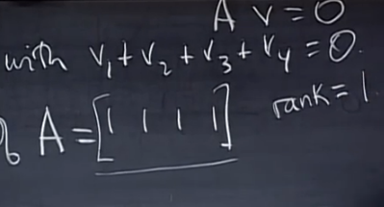

Note: the dimension of zero space is 0.

Graph = {notes, edges}

Lecture 12

Graphs & networks

Incidence matrices

Kirchhoff’s Current Laws

Graphs of all websites, telephones,

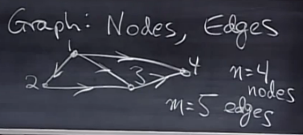

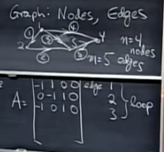

It is a sparse matrix, there is only two numbers in each row.

If all the columns are independent, the rank r = n, and in the null space there is only zero.

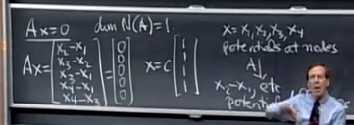

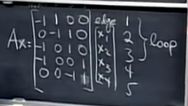

Since dim N(A) = 1, we set x4 = 0, so there are only three columns left. And these columns are independent

ATy = 0

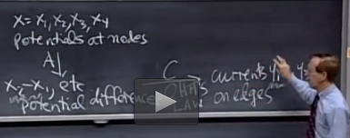

Potentials at nodes

Currents on edges

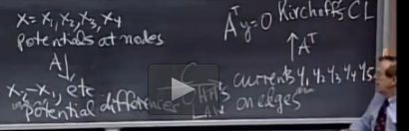

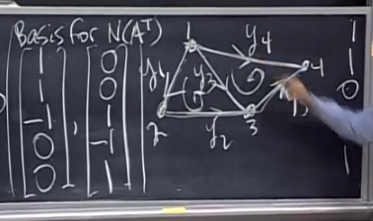

A graph with no loops is called a tree

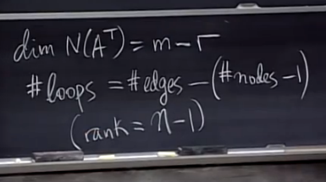

#nodes - #edges + #loops = 1 (Euler’s formula)

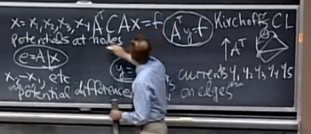

Lecture 13

Review for exam 1 with an emaphasis on Chapter 3

If the N(A) is zero, then A is a square.

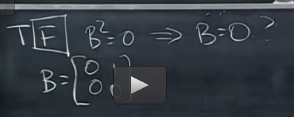

N (CD) = N (D) if C is invertible

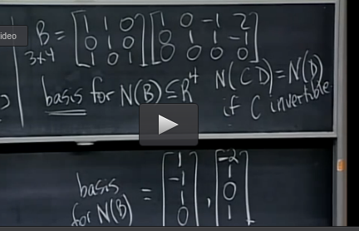

To find out the basis for N(B), find the special solutions

Question: rank of N(B) is 2, but the dimension of N(B) is 4 since it has 4 components in the vectors.

Lecture 14

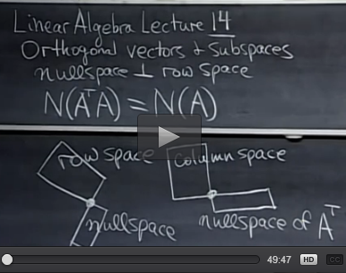

The angles between these subspaces are 90 degree. (orthogonal vectors)

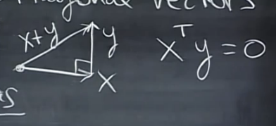

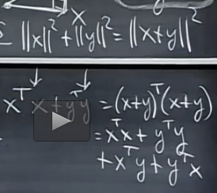

Finally, xTy = 0

Subspace S is orthogonal to subspace T: every vector in S is orthogonal to vectors in T.

Q: Row space of A is orthogonal to null space of A. why?

Ax = 0

This equation tells us all the row vectors in A is orthogonal to x.

Nullspace and row space are orthogonal complements in Rn

Q: “Solve” Ax = b when there is no solution. m > n.

ATA is square, symmetric matrix. (ATA)T = ATA

Q: is it invertible? What is the basis?

ATAx = ATb

N(ATA) = N(A), rank of ATA = rank of A

Conclusion: ATA is invertible when the nullspace of A is zero only, which says that A has only independent columns.

My question is why?

Lecture 15

Projections onto subspaces

Projections

Least squares

Projection on matrix

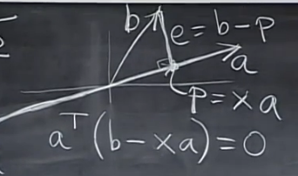

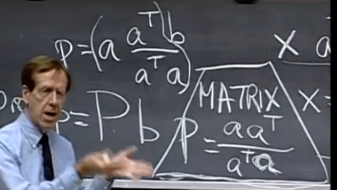

What the properties of the matrix capital p (P, projection matrix)?

C(P) = line through a, why?

Rank (P) = 1, why?

PT = P. (P is symmetric.)

P2 = P

Why project?

Because Ax = b may have no solution. Instead project b onto col space, then solve Ax = p = Pb

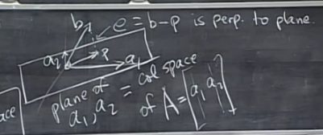

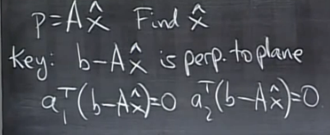

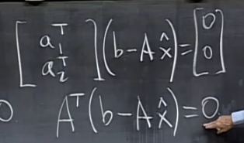

Thus, b – Ax in in N(AT), that means, b – Ax is orthogonal to C(A).

ATAx = ATb

x = (ATA)-1 ATb

p = Ax = A (ATA)-1 ATb

P = A (ATA)-1 AT

If A is a square matrix, then A-1 exists, if not, then the formula of P stays.

Remember

PT = P. (P is symmetric.)

P2 = P

Application:

Least square: fitting by a line

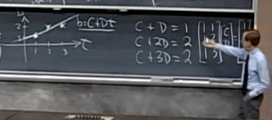

A typical equation but with no solution. however, we are seeking a best solution. we want to solve this equation because we can solve it.

ATAx = ATb

Lecture 16

Projections matrix: P = A (ATA)-1 AT

Least squares and best straight line

If b is in the column space, Pb = b

If b is orthogonal to the column space, then Pb = 0. Because if b is orthogonal to the column space, then b is in the N(AT)

p = Pb

p + e = b

then, e = (I - P)b, where (I - P) is the projection matrix onto the orthogonal space of the column space, which is N(AT)

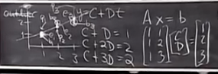

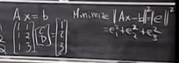

C D are estimates, we need find C and D, and P (Me: it also explains why we need the formula of equations, so the software can find the parameters to solve)

Use this equation below:

ATAx = ATb (this is important whenever you use parameters to do fitting, ATA is symmetric and invertible)

After finding C and D (or equally the relationships between C and D)

Finally, the equation is obtained.

Go back to the minimize equation, find the error e

Then find p = b – e

If A has independent columns, then ATA is invertible

Suppose ATAx = 0, to prove the statement, x must be 0.

xTATAx = 0

(Ax)T(Ax) = 0

Ax = 0

x = 0.

Columns are definitely independent if they are orthogonal normal vectors ( or called perpendicular unit vectors).

Lecture 17

Orthogonal basis q

Orthogonal matrix Q (we only call it when Q is square)

Gram-Schmidt A -> Q

Orthonormal vectors

qi qj = 0 (if i != j) or 1 (if i = j)

QTQ = I

If Q is square then QTQ = I, which tells us that QT = Q-1

Why do we need the orthogonal matrix?

Q has orthonormal columns, project onto its column space.

P = Q (QTQ)-1 QT = Q QT

P = I if Q is square (similar to Q-1).

P = symmetric matrix

(Q QT) (Q QT) = Q QT

Remember ATAx = ATb

Now A = Q, QTQx = QTb, x = QTb, which means xi = qTib

In the next half of the lecture, I will use the independent columns, and make them orthogonal. Can I do that?

Gram-Schmidt

Start with independent vectors a, b -> orthogonal vectors A, B -> orthonomal vectors q1 = A / ||A|| and q2 = B / ||B||

A = a,

B = b – Pb = b - $\frac{A^{T}b}{A^{T}A}$ A

Start with independent vectors a, b, and c -> orthogonal vectors A, B, and C -> orthonomal vectors q1 = A / ||A||, q2 = B / ||B|| and q3 = C / ||C||

A = a,

B = b – PA = b - $\frac{A^{T}b}{A^{T}A}$ A

C = c - $\frac{A^{T}c}{A^{T}A}$ A - $\frac{B^{T}c}{B^{T}B}$ B

Remember the elimination gives out A = LU

A = QR, where R is a triangular matrix

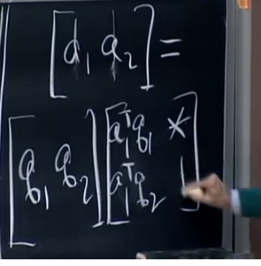

Lecture 18

Determinants det A = |A|

Properties 1, 2, 3, 4 – 10

Plus/minus signs

Properties

1, Det I = 1

2, exchange rows: reverse sign of det

det permutation matrix = 1 (# of exchange is even) or -1 (# of exchange is odd)

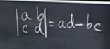

3a, if multiple the first row by the constant t, then det’ = t * det

3b, det is a linear combination of linear of each row

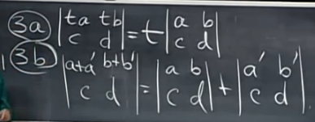

4, 2 equal rows -> det = 0

exchange those rows -> same matrix

5, subtract l * row(i) from row k, det doesn’t change.

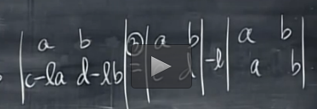

6, row of zeros -> det A = 0

7, 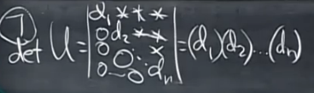

Do the elimination, then product the pivots to find the det (hint: rule 1)

8, A = LU. det A = 0 when A is singular (hint: row of zeros). det A != 0 when A is invertible.

9, det (AB) = det (A) * det (B). thus, det (A-1) = 1/ det (A)

10, det (AT) = det (A)

To prove |AT| = |A|, |UTLT| = |LU|, |LT| |UT| = |L| |U|, since L and U are triangular matrix,

The permutations are either even or odd (Property 2)

Lecture 19

Formula for det A (n! terms)

Cofactor formula

Tridiagonal matrices

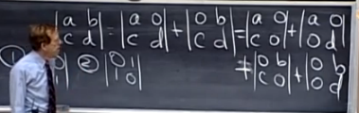

1, Det I = 1

2, exchange rows: reverse sign of det

det permutation matrix = 1 (# of exchange is even) or -1 (# of exchange is odd)



3a, if multiple the first row by the constant t, then det’ = t * det

3b, det is a linear combination of linear of each row

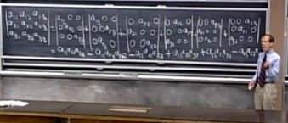

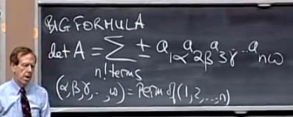

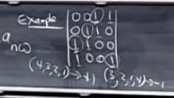

Cofactor: is the determinant of the small guy

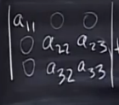

Cofactor of Cij = aij = plus (if i + j is even) / minus (if i + j is odd) det (n-1 matrix with row i and col j erased)

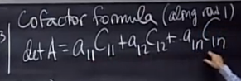

Example: the diangular matrix

Lecture 20

Formula for A-1

Cramers rule for x = A-1b

|Det A| = volume of box

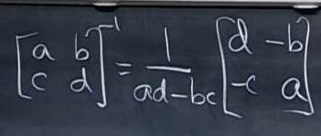

$$A^{-1}= \frac{1}{\det{A}} C^{T}$$

$$AC^{T}=\left(\det{A}\right)I$$

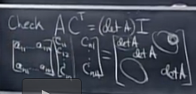

The reason why we got 0 is that it is similar to do the calculation for det A while A has two equal rows.

Application #2

Ax = b

x = A-1b = b

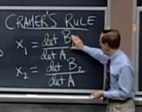

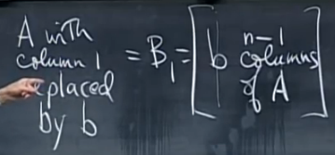

Bj is the column j of A replaced by b

However, we do not use the cramer’s rule for calculation

Application #3

|Det A| = volume of box, the sign of det A tells us the right hand side order or the left hand side order.

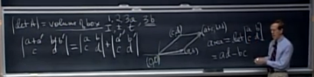

Lecture 21

Eigenvalues, eigenvectors

det [A - λI] = 0

Trace = λ1 + λ2 + λ3 + … + λm + λn

Eigenvectors

Ax = λx (we have two unknowns λ and x here)

If A is singular, λ is eigenvalue.

What are x’s and λ’s for projection matrix?

Any x in the plane: Px = x, where λ is 1, P = A (ATA)-1 AT

Any x perpendicular to the plane: Px = 0x, where λ is 0.

e.g., permutation matrix

A = [0 1; 1 0]

Ax = λx

Solution 1: x = [1; 1], λ = 1

Solution 2: x = [-1; 1], λ = -1

Fact: the sum of λ’s equals a11 + a22 + a33 + … + ann

How to solve the equation and find x and λ?

Ax = λx

(A - λI) x = 0

A - λI is singular, thus, det (A - λI) = 0.

Find λ first,

If Ax = λx, then (A + 3I) x = (λ + 3) x

If Ax = λx, B has eigenvalues α (By = αy)

Then it is wrong to say that A + B, AB

Example

Q = [ 0 -1; 1 0] (90 degree rotation)

Trace is 0 + 0 = λ1 + λ2

Det = 1 = λ1λ2

Lecture 22

Ax = λx

A – λI is singular

Diagonaling a matrix S-1AS =Λ, where capital lamda is the diagonal eigenvalue matrix

Powers of A /equation uk+1 = A uk

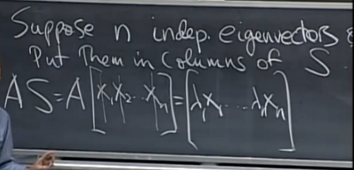

Thus, AS = SΛ

S-1AS =Λ, where S is invertible because we assume S is a matrix with n eigenvectors

A = SΛS-1

A2 = SΛS-1 SΛS-1 = SΛ2S-1

(A2x = λAx = λ2x)

Ak = SΛS-1 SΛS-1 ….= SΛkS-1

In summary, eigenvalues and eigenvectors are good at telling power of the matrix

Theorem

Ak -> 0 as k -> infinity if the absolute of λ < 1

A is sure to have n independent vectors and be diagonalizable if all the λ’s are different (no repeated λ’s).

If I have repeated eigenvalues, I may or may not have n independent eigenvectors.

Example

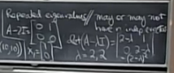

uk+1 = A uk

start with given vector u0

u1 = A u0

u2 = A u1 = A2 u0

uk = Ak u0

To really solve, write

u0 = c1x1 + c2x2 + … + cnxn = Sc, where xi is a vector

A u0 = c1λ1x1 + c2λ2x2 + … + cnλnxn

u100 = A100 u0 = c1(λ1)100x1 + c2(λ2)100x2 + … + cn(λn)100xn = Λ100 u0

Fibonacci example: 0, 1, 1, 2, 3, 5, 8, 13, …

What is F100 = ?

Fibonacci rule: Fk+2 = Fk+1 + Fk

Trick:

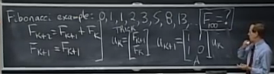

Lecture 23 differential equations and exp (At)

Differential eqns du/dt = Au

Exponential eAt of a matrix

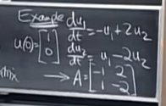

Me: u = ceAt ?

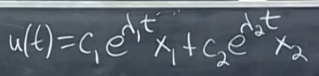

I am not following this lecture, need to read the textbook

Lecture 24 markov matrices; fourier series

Markov matrices

Steady state

Fourier series and projections

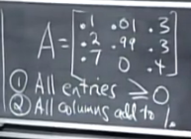

We are interested in the eigenvalues and eigenvectors

for the steady state corresponds to λ = 1

Property #2 guarantees that eigenvalue is 1

key point :

1. λ = 1 is an eigenvalue. (Why?)

2. all other |λ| < 1

Remember uk = Ak u0 = c1(λ1)kx1 + c2(λ2)kx2 + …

When λ = 1, all other |λ| < 1, then uk = Ak u0 🡪 c1x1, which is the x1 part of u0

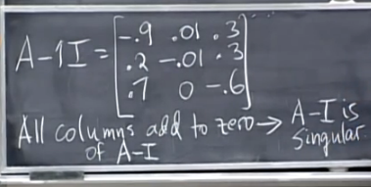

A singular matrix means the columns of A are dependent, there is solution (in this example, (1, 1, 1) is in N(AT)) other than 0 to Ax = 0

Eigenvalues of A is the same as the eigenvalues of AT

To prove: det (A - λI) = 0, det (A - λI)T = 0, det (AT - λI) = 0

uk+1 = A uk, where A is Markov

find eigenvalues, then eigenvectors, then use uk = Ak u0 = c1(λ1)kx1 + c2(λ2)kx2 + …, where ci can be obtained from the initial conditions.

Projections (or expansion) with orthonomal basis (q1, q2, q3, q4, …, )

Any V = x1 q1 + x2 q2 + x3 q3 + … + xn qn

(q1)T V = x1 (q1)T q1 + (q1)T x2 q2 + (q1)T x3 q3 + … + (q1)T xn qn = x1 (q1)T q1 + 0 = x1

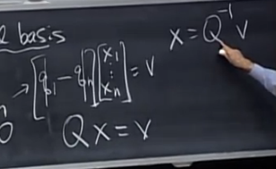

Fourier series (instead of vector, orthonormal basis, we can use function basis) F(x) = F(x + 2pi)

F(f) = a0 + a1 cos(x) + b1 sin (x) + a2 cos(2x) + b2 sin (2x) + ….

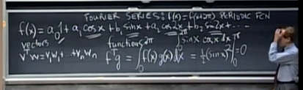

Library textbook reading 2nd week

Multiply AB: every column of B is multiplied by A

Dot product = inner product

Matrix multiplication

* Matrix A times column of B:

A [ b1 b2 b3 … bn ] = [ Ab1 Ab2 Ab3 … Abn]

* Row times matrix

[ row i of A ] [ B ] = [ row i of AB ]

* Rows times columns, which is the usual way, gives dot products. While columns times rows, gives out matrices.

Multiplication rulw

AB != AB

(AB)C = A(BC)

Central question:

When is A has an inverse?

Notes about inverse matrices

1. The inverse exists if and only if elimination produces n pivots
2. Suppose there is a nonzero vector x such that Ax = 0. Then A cannot have an inverse. That is to say, the rank of the matrix A: r = n.
3. A matrix is invertible if its determinant is not zero.
4. A diagonal matrix has an inverse provided no diagonal entries are zero.

(AB)-1 =B-1A-1

Inverse of an elimination matrix

For square matrices, if AB = I, then automatically BA = I

A-1 might not be explicitly needed. The equation Ax = b is solved by x = A-1b. but it is not necessary or efficient to compute A-1 and multiply it times b. Elimination goes directly to x.

Calculating A-1 by Gauss-Jordan elimination

Do the elimination to the augmented matrix

After the elimination when we got the pivots on diagonal, gauss would finish y back substitution. While Jordan is to continue with elimination. He goes all the way to the row reduced echelon form, by adding rows to the rows above them, producing zeros above the pivots.

At last, [ K I ] 🡪 [ I K-1 ]

Many key ideas of linear algebra are really factorizations of a matrix. The original matrix A becomes the product of two or three special matrices.

The first factors L and U: A = LU, which is elimination without row exchanges. The upper triangular U has the pivots on its diagonal. The lower triangular L has all 1(one)’s on its diagonal. The multipliers lij are below the diagonal of L.

Earlier, we worked on A and b at the same time. No problem with that – just augment to [ A b ]. But most computer codes keep the two sides separate.

The very practical question is cost – or computing time

Elimination on A requires about n3/3 multiplications and n3/3 subtractions

Solve each right side needs n2 multiplicaitons and n2 subtractions

AT is much easier than the A inverse.

Note: MATLAB’s symbol for the transpose of A is A’. Typing [ 1 2 3 ] gives a row vector and the column vector is v = [ 1 2 3 ]’. To enter a matrix M with second column w = [ 4 5 6 ]’ you could define M = [ v w ].

AT is invertible exactly when A is invertible

We have a better way to write xy without using that unprofessional dot.

T is inside: The inner product is xTy (1 x n)(n x 1), this is a number

T is outside: The outer product is xyT (n x 1)(1 x n), this is a matrix

Symmetric matrices have AT = A, that means aij = aji

The inverse of a symmetric matrix is also symmetric

Anti-symmetric matrices have AT = A

The difference matrix can be viewed as a derivative A = d/dt, then AT = -d/dt

For the symmetric matrix, its (i, j) entry across the main diagonal equals its (i, j) entry.

Symmetric products RTR and RRT and LDLT

Most scientific problems that start with a rectangular matrix R end up with RTR and RRT or both. As in least squares.

If A = AT is factored into LDU with no row exchanges, then U is exactly LT. that is to say, the symmetric factorization of a symmetric matrix is A = LDLT

Me question: symmetric matrices makes elimination faster, because we can work with half the matrix (plus the diagonal). ?? why faster

If a matrix P has a single “I” in every row and every column, then P is a permutation matrix. Any product P1P2 is again a permutation matrix.

Important: P-1 is also a permutation matrix. P-1 is always the same as PT.

There are n! permutation matrices of size n. half even, half odd. (even means the number of row exchange is even).

**Chapter 3** Vector spaces and subspaces

Matrix involve vectors, and spaces of vectors.

Without seeing vector spaces and especially their subspaces, you have not understood everything about Ax = b.

The space of Rn consists of all column vectors v with n components.

The components of v are real numbers. A vector whose n components are complex numbers lies in the space Cn.

A real vector space is a set of vectors together with rules for vector addition and for multiplication by real numbers.

M: The vector space of all real 2 by 2 matrices

F: the vector space of all real functions f(x)

Z: the vector space that consists only of a zero vector

The ordinary column vectors are vectors with n components – but maybe not all of the vectors with n components. They are in subspaces of Rn.

A subspace of a vector space is a set of vectors (including 0) that satisfies two requirements: if v and w are vectors in the subspace and c is any scalar, then

(1) v + w is in the subspace;

(2) cv is in the subspace. Especially c = 0.

That means, **all linear combinations stay in the subspace.**

Here is a list of all the possible spaces of R3:

Z: the single vector (0,0,0);

L: any line through (0,0,0);

P: any plane through (0,0,0);

R3: The whole space

Ax = b

Remember that Ax is a combination of the columns of A, b are the vectors that can be written as A times vector x. those b’s are in the column space of A.

The column space of A is a vector space made up of column vectors. The column space C(A) contains of all linear combinations of the columns. C(A) is a subspace of Rm if A is an m by n matrix. The word subspace justified by taking all linear combinations.

If b is in the C(A), there is a solution. If not, there is no solutions. One possibility is the first column itself.

C(A) is to describe all the attainable right sides b.

N(A) is to describe all the solutions of Ax = 0.

The nullspace of A consists of all solutions to Ax = 0. Null space is also a subspace because all of the linear combinations of special solutions are in the nullspace. However, the solutions to Ax = 0 does not form a subspace because x = 0 is not in this space.

Me: How can I imagine the solutions? Since C(A) is all linear comnbinations of the columns.

The best way to describe the nullspace is to compute special solutions to Ax = 0, then multiple it by a constant. The free variable is assigned a free choice. **The free components correspond to columns without pivots.** When there is a free variable, it can be set to 1.

The fact that the nullspace is the zero space tells us that the columns of A are independent. No combination of columns gives the zero vector (except the zero combination). All columns have pivots, and no columns are free.

In summary, there are at most m pivots. With n > m, the system Ax = 0 has a nonzero solution. Actually there are infinitely many solutions, since any multiple cx is also a solution. The nullspace contains at least a line of solutions. With two free free variables, there are two special solutions and the nullspace is even larger.

The null space is a subspace. Its “dimension” is the number of free variables. this central idea – the dimension of a subspace – is defined and explained later.

Question: the dimension of the nullspace?

The reduced row echelon matrix (rref) has zeros above the pivots as well as below

MATLAB code: [ R, pivcol ] = rref (A)

**The rank and the row reduced form**

Definition 1: The true size of A is given by its rank. The rank of A is the number of pivots. This number is r.

Definition 2: the matrix has r independent rows (the pivot rows). They also have r independent columns (the pivot columns).

Definition 3: the rank r is the dimension of the column space. It is also the dimension of the row space.

Every free column is a combination of earlier pivot columns. (this is equal to say about the special solution to Ax = 0)

The pivot columns are not combinations of earlier columns. The free columns are combinations of earlier columns. These combinations are the special solutions.

Ax = 0, that means, row spaces is line, nullspace is the perpendicular plane. That is to say. C(AT) is perpendicular to N(A).

There is a special solution for every free variable.

Ax = 0 has r pivots and n – r free variables: n columns minus r pivot columns. The nullspace matrix N contains the n – r special solutions. Then AN = 0.

How to determine the pivot columns (I) and free columns (F) in an “algebra way”?

1. The pivot columns are not combinations of earlier columns of A
2. The free columns are combinations of earlier columns (F tells the combinations)

The complete solution to Ax = b

The particular solution to Ax = b is that: free variables = zero, pivot variables from b’.

Remember the special solutions to Ax = 0 is that: free variables = 1 at a time.

**Independence, basis and dimension**

The true dimension of the column space is the rank r.

A basis is a set of independent vectors that “span the space”. Every vector in the space is a unique combination of the basis vector.

Linear independence: the columns of A are linearly independent when the only solution to Ax = 0 is x = 0. No other combination Ax of the column gives the zero vector. That is to say, the nullspace N(A) contains only the zero vector. That means, the rank of the column space is equal to n. if r < n, then the columns of A are dependent. However, those pivot columns are independent.

A set of vectors spans a space if their linear combinations fill the space.

The first subspace in this book was the column space.

The second subspace is the row space, which is composed of the combinations of the rows C(AT).

A basis for a vector space is a sequence of vectors with two properties:

The basis vectors are linearly independent and they span the space.

Therefore, there is one and only one way to write v as a combination of the basis vectors.

The columns of every invertible n by n matrix give a basis for Rn:

Invertible matrix, independent columns, column space is Rn;

Singular matrix, dependent columns, column space is not Rn

The vectors v1, …, vn are a basis for Rn exactly when they are the columns of an n by n invertible matrix. Thus Rn has infinitely many different bases.

The pivot columns of A are a basis for its column space.

Question from me: the column spaces of A and R are different. Their bases are diferent. But their dimensions are the same.??

Example: find bases for the column and row spaces of this rank two matrix:

$$R= \left[\begin{matrix}\begin{matrix}1 & 2 \\ 0 & 0 \\ 0 & 0\end{matrix} & \begin{matrix}0 & 3 \\ 1 & 4 \\ 0 & 0\end{matrix}\end{matrix}\right]$$

Answer: columns 1 and 3 are the pivot columns. They are a basis for the column space (of R!). the vectors in that column space all have the form b = (x,y,0). The column space of R is the “xy plane” inside the full 3-dimensional xyz space. That place is not R2, it is a subspace of R3. Columns 2 and 3 are also a basis for the same column space. Which pairs of columns of R are not a basis for its column space?

The row space of R is a subspace of R4. The simplest basis for that row space is the two nonzero rows of R. the third row (the zero vector) is in the row space too. But it is not in a basis for the row space. The basis vectors must be independent.

The number of vectors, in any and every basis, is the “dimension” of the space. There are many choices for the basis vectors, but the number of basis vectors does not change. The number of basis vectors counts the “the degree of freedom” in the space.

The dimension of a space is the number of vectors in every basis.

In the language of linear algebra, we never say the rank of a space, or the dimension of a basis, or the basis of a matrix. Those terms have no meaning. It is the dimension of the column space that equals the rank of the matrix.

In differential equations, d2y/dx2 = 7 has s space of solutions. One basis is y = ex and y = e-x. the dimension is 2 because of the second derivative.

The dimension of the whole n by n matrix space is n2

The dimension of the subspace of upper triangular matrices is (n2 + n)/2

The dimension of the subspace of diagonal matrices is n

The dimension of the subspace of symmetric matrices is (n2 + n)/2

The solutions of y’’ = 2 don’t form a subspace – the right side b = 2 is not zero.

The main theorem in this chapter connects rank and dimension. The rank of a matrix is the number of pivots. The dimension of a subspace is the number of vectors in a basis.

Four fundamental subspaces

The row space is C(AT), a subspace of Rn.

The column space is C(A), a subspace of Rm.

The nullspace is N(A), a subspace of Rn.

The left nullspace is N(AT), a subspace of Rm.

Two in Rn and two in Rm

In Rn the row space and nullspace have dimensions r and n – r.

In Rm the column space and left nullspace have dimensions r and m – r.

The row space and column space have the same dimension r.

A reduced to R

A has the same row space as R. same dimension r and same basis.

A has different column space from R. but same dimension r.

A has the same nullspace as R. same dimension n – r and same basis.

Every rank one matrix has the special form A = uvT = column times row.

Chapter 4

**Orthogonality** of the four subspaces

Orthogonal subspaces, orthogonal bases, and orthogonal matrices

Orthogonal vectors: vTw = 0

Orthogonal subspaces: vTw = 0 for all v in V and all w in W.

The row space of A is perpendicular to the nullspace of A. Both of them are orthogonal subspaces of Rn.

The column space of A is perpendicular to the nullspace of AT.

When b is outside the column space – we want to solve Ax = b and cannot do it – then this nullspace of AT comes into its own. It contains the error e = b – Ax in the least – squares solution.

When a vector is in two orthogonal subspaces, it must be zero. It is perpendicular to itself. Therefore, zero is the only point where the nullspace meets the row space.

The fundamental subspaces are more than just orthogonal in pairs. Their dimensions are also right. E.g., the correct dimensions r and n – r must add to n. they are orthogonal complements.

The orthogonal complement of a subspace V contains every vector that is perpendicular to V.

The point of “complements” is that every x can be split into a row space component xr and a nullspace component xn. When A multiples x = xr + xn, this goes:

The nullspace component goes to zero: Axn = 0

The row space component goes to the column space: Axr = Ax

Important: every vector b in the column space comes from one and only one vector x in the row space.

There is an r by r invertible matrix hiding inside A, if we throw away the two nullspaces. From the row space to the column space, A is invertible.

Question: singular value decomposition?

Properties of a basis:

1st, linearly independent vectors

2nd, span the space

One product of a basis produces the other.

Any n independent vectors in Rn must span Rn. So they are a basis.

Any n vectors that span Rn must be independent. So they are a basis.

When the vectors go into the columns of an n by n square matrix A:

Any n independent vectors in Rn must span Rn. So they are a basis. So Ax = b is solvable.

Any n vectors that span Rn must be independent. So they are a basis. So Ax = b has only one solution.

Uniqueness implies existence and existence implies uniqueness.

Then, A is invertible.

Each x in Rn is the sum xr + xn of a row space vector xr and a nullspace vector xn.

Projection

May we start this section with two questions?

1st what are the projections of b = (2,3,4) onto the z axis and the xy plane?

2nd, what matrices produce those projections onto a line and a plane?

The first question aims to show that projections are easy to visualize. The second question is about “projection matrices” – symmetric matrices with P2 = P. the projection of b is Pb.

The project is to find the part p in each subspace, and the projection matrix P that produces that part p = Pb.

Our problem is to project any b onto the column space of any m by n matrix.

Three steps will lead to all projection matrices:

1st, Find x hat, using a (b – p) = 0, where p = x hat * a.

$$x= \frac{a∙b}{a∙a}= \frac{a^{T}b}{a^{T}a}$$

2nd, Find the projection p,

$$p=xa$$

If b = a, then x = 1, the projection of a onto a is itself. Pa = a.

If b is perpendicular to a then aTb = 0. The projection is p = 0.

The error vector between b and p is e = b – p. those vectors p and e will add to b. the vector b s split into two parts – its component along the line is p, its perpendicular part is e. the distance between the b and the subspace is ||e||.

3rd, Then find the matrix P.

$$p= \frac{a^{T}b}{a^{T}a}a= a \frac{a^{T}b}{a^{T}a}= Pb$$

$$P= \frac{aa^{T}}{a^{T}a}$$

P is a column times a row, then divided by the number aTa. The projection matrix P is m by m.

P2 = P. because projection a second time does not change anything.

When P projects onto one subspace, I – P projects onto the perpendicular subspace.

The error vector b – Ax is perpendicular to that column space.

Therefore b – Ax is in the nullspace of AT. This means AT(b - Ax) = 0. The left nullspce is important in projections. The nullspace of AT contains the error vector e = b - Ax. The vector b is split into the projection p and the error e.

In our experience, a problem that involves a rectangular matrix almost always leads to ATA. when A has independent columns, ATA is invertible.

ATA is invertible if and only if A has linearly independent columns.

ATA has the same nullspace as A. When the columns of A are linearly independent, its nullspace contains only the zero vector. Then ATA, with this same nullspace, is invertible.

When A has independent columns, ATA is square, symmetric, and invertible.

Least Squares Approximations

When the length of e is as small as possible, x hat is a least squares solution to Ax = b.

When Ax = b has no solution, multiple by AT and solve ATAx(hat) = ATb.

How to minimize the error?

1st. by geometry

2nd, by algebra. Solve Ax(hat) = p, where b = p + e.

3rd, by calculus. This is actually the same as the method by algebra. The partial derivatives of ||Ax – b||2 are zero when ATAx(hat) = ATb.

4th, by gradient descent

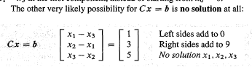

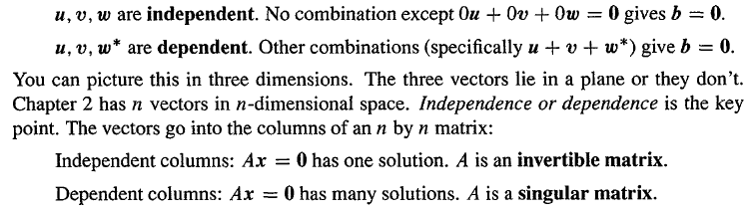

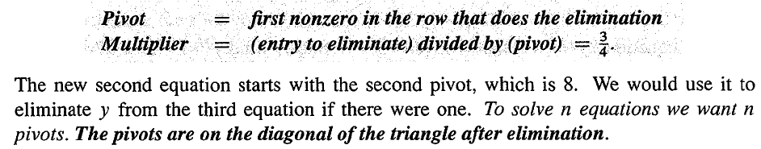

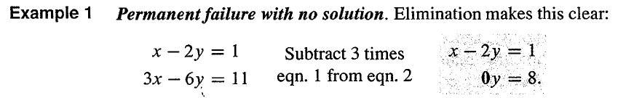

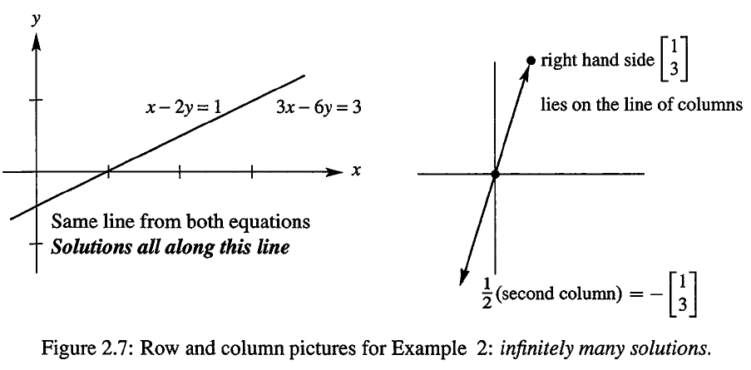

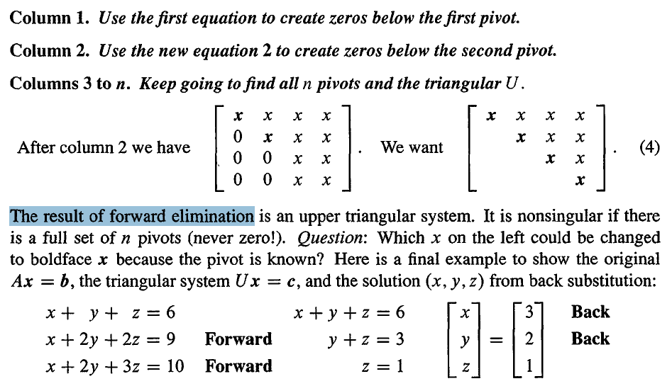

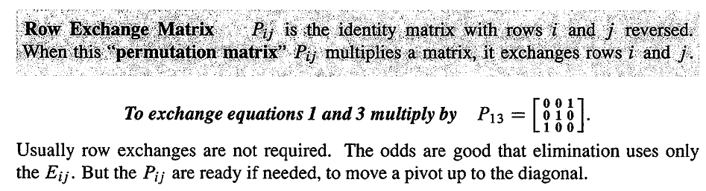

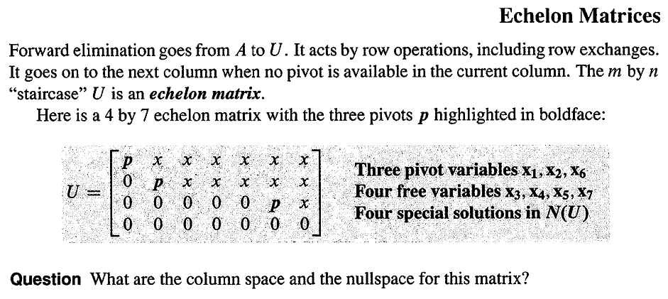

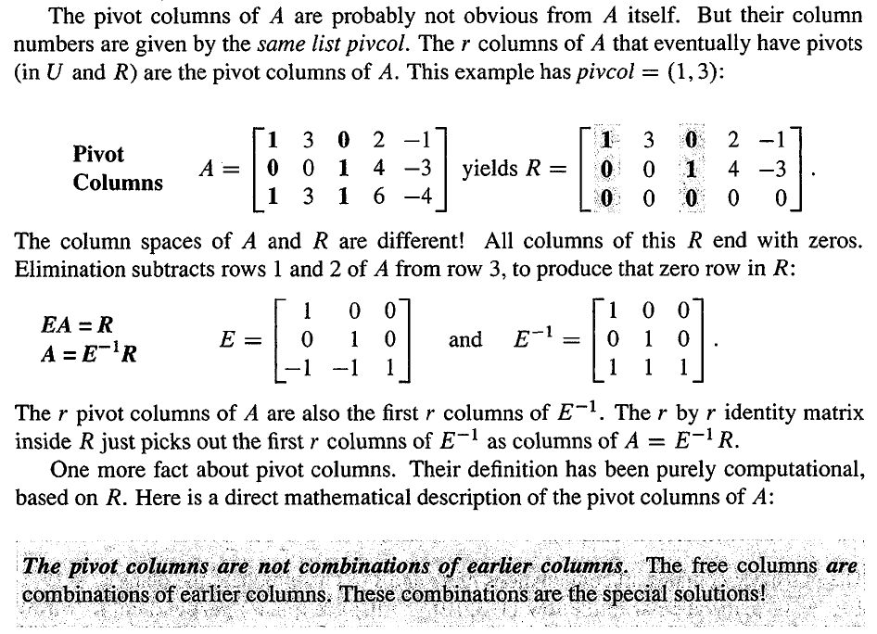

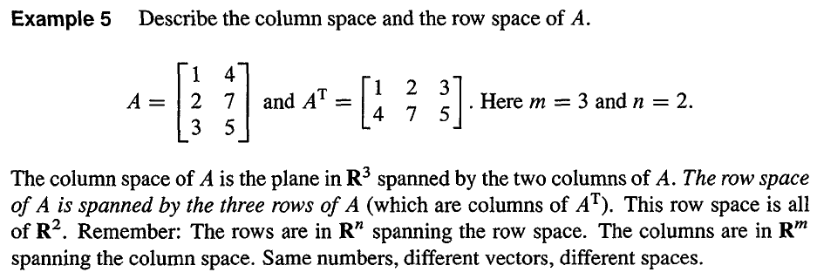

Fitting a line is the clearest application of least squares. The derivatives of ||Ax - b||2 give the n equations ATAx = ATb. The derivative of a square is linear. That is why the method of least squares is so popular.

The Gram-Schmidt process: orthogonalize the columns in advance

In the fitting line example: Orthogonal columns when sum of xi adds to zero are useful. The shifted X’s are produced by subtracting away the average x’s. with the columns orthogonal, ATA is diagonal. It’s entries are m and sum of X square.

The best C and D have direct formulas:

$$C= \frac{b1+b2+…+bm}{m}$$

$$D= \frac{b1X1+b2X2+…+bmXm}{X_{1}^{2}+ X_{2}^{2}+…+ X_{m}^{2}}$$

Then the best line is C + DX or C + D(x - X)

Fitting by a parabola

Choosing the best parabola is still a problem in linear algebra.

Y = C + Dx + Ex2

Orthogonal bases and gram-schmidt

Orthogonality makes it easy to find x and p and P. dot products are zero – so ATA becomes a diagonal matrix.

We will pick combinations of the original vectors to produce right angles. Those orginal vectors are the columns of A. the new orthogonal vectors will be the columns of a new matrix Q.

The vectors q1, q2, … , qn are orthonormal if

$$q_{i}^{T}q_{j}= f\left(x\right)=\left\{\begin{aligned}0, when i !=j (orthogonal vectors) \\ 1, when i=j (unit vectors)\end{aligned}\right.$$

A matrix with orthonormal columns is assigned the special letter Q (orthonormal matrices), which is easy to work with because QTQ = I. Q is not required to be square.

When Q is square (orthogonal matrix), QTQ = I means that QT = Q-1: transpose = inverse.

If Q is rectangular, is only an inverse from the left. QTQ = I.

Example

Rotation:

$$Q= \left[\begin{matrix}cosθ & -sinθ \\ sinθ & cosθ\end{matrix}\right]$$

Permutation: every permutation matrix is an orthogonal matrix.

Reflection:

If u is any unit vector, set Q = I – 2uuT.

If Q has orthonormal columns (QTQ = I), it leaves lengths unchanged:

Same length: ||Qx|| = ||x|| for every vector x.

Q also preserves dot products: (Qx)T(Qy) = xTy.

Projections using orthogonal bases: Q replaces A.

Then the least squares solution of Qx = b is x = QTb. The projection matrix is P = QQT. p = QQTb.

There are no matrices to invert. This is the point of an orthonormal basis.

When Q is orthonormal matrix, p = QQTb = b = .

This is the foundation of Fourier series and all the great transforms of applied mathematics. They break vectors or functions into perpendicular pieces. Then by adding the pieces, the inverse transform puts the function back together.

The Gram-Schmidt Process

The point of this section is that “orthogonal is good”.

But the question is: how do we find a way to create orthonormal vectors?

Start with three independent vectors a, b, c

1st, choose A = a,

2nd, B must be perpendicular to A, use the projection method:

$$B=b- \frac{A^{T}b}{A^{T}A} A$$

B is called the error vector

3rd, C

$$C=c- \frac{A^{T}c}{A^{T}A} A - \frac{B^{T}c}{B^{T}B} B$$

4th, three orthonormal vectors q1 = A/||A||, q2 = B/||B||, q3 = C/||C||.

The idea is that to substract from every new vector its projections in the directions already set. That idea is repeated at every step.

The factorization A = QR = (orthogonal Q)(upper triangular R)

The goal of this chapter is: the matrix A with a, b, c, and the matrix q1, q2, q3, what is the relationship between them?

Insert p236 here

Then R = QTA is upper triangular because later q’s are orthogonal to earlier a’s.

The i, j entry of R is row i of QT times column j of A. this is the dot product of qi with aj.

So any m by n matrix A with independent columns can be factored into QR. The m by n matrix Q has orthonormal columns, and the square matrix R is upper triangular with positive diagonal.

Then, the least squares equation ATAx = ATb simplies to Rx = QTb.

The Gram-Schmidt is still the good process to understand, even if the reflections or rotations lead to a more perfect Q.

Chapter 5 Determinants

1st, The determinant is zero when the matrix has no inverse.

2nd, Determinants can also be used to find formulas for inverse matrices and pivots and solutions to Ax = b, though we seldom use it because the elimination is faster.

3rd, The product of the pivot is the determinant.

The applications in determinants

1st, Determinants give A-1 and A-1b (Cramer’s Rule)

2nd, When the edges of a box are the rows of A, the volumn is |det A|

3rd, For n special numbers lamda, called eigenvalues, the determinants of A – lamda I is zero. This is truly important application and if fills Chapter 6.

How determinants equal volumes? Expand an n-dimensional box by t and its volume increases by tn.

If A is triangular then det A = product of diagonal entries.

det AT = det A

det (AB) = det(A) det(B)

det (A + B) !!!!= det A + det B

There are three ways to find determinants: pivots, big formula, and cofactors.

The computer find the determinant from the pivots.

Pivots from determinants: insert picture here.

Pivots are good but hard to connect them to the original aij. So there is a single explicit formula for the determinant directly from the entries aij.

In the big formular, each term has one entry from each row, it also has one entry from each column.

Big formular = det A = $\sum{(\det{P})a_{1α}}a_{1β}a_{1γ}… a_{1n}$

A determinant of order n is a combination of determinants of order n – 1.

Cofactor formula: det A = $a_{i1}C_{i1}{+ a}_{i2}C_{i2}+…+ a_{in}C_{in}$

Each cofactor Cij (order n – 1, without row i and column j ) includes its correct sign:

Cofactor $C_{ij}= {(-1)}^{ij}\det{M_{ij}}$

Cramer’s Rule, Inverse, and Volumes

This section solves Ax = b by algebra and not by elimation.

Cramer’s Rule: if det A is not zero, Ax = b is solved by determinants:

$$x_{1}= \frac{\det{B_{1}}}{\det{A}} , x_{2}= \frac{\det{B_{2}}}{\det{A}}… x_{n}= \frac{\det{B_{n}}}{\det{A}}$$

Where the matrix $B_{j}$ has the j th column of A replaced by the vector b.

When solving AA-1 = I, the aij of A-1 is the cofactor of Cji divided by det A:

Formular for A-1

$${(A^{-1})}_{ij}= \frac{C_{ji}}{\det{A}} and { A}^{-1}= \frac{C^{T}}{\det{A}}$$

The inverse of a triangular matrix is triangular. Cofactors give a reason why.

We know the corners (x1,y1), (x2,y2), and (x3,y3) of a triangle, what is the area?

Using the corners to find the base and height is not a good way.

The triangle with corners (x1,y1), (x2,y2), and (x3,y3) has area = determinant /2.

Area of triangle = $\frac{1}{2} \left|\begin{matrix}x1 & y1 & 1 \\ x2 & y2 & 1 \\ x3 & y3 & 1\end{matrix}\right|$

Proof: a parallelogram starting from (0,0) has area = 2 by 2 determinant.

We show that the area has the same properties 1-2-3 as the determinant. Then area = determinant. Remember that those three rules defined the determinant and led to all its other properties.

Insert calculus example

The cross product $μ × ν$ is a vector.

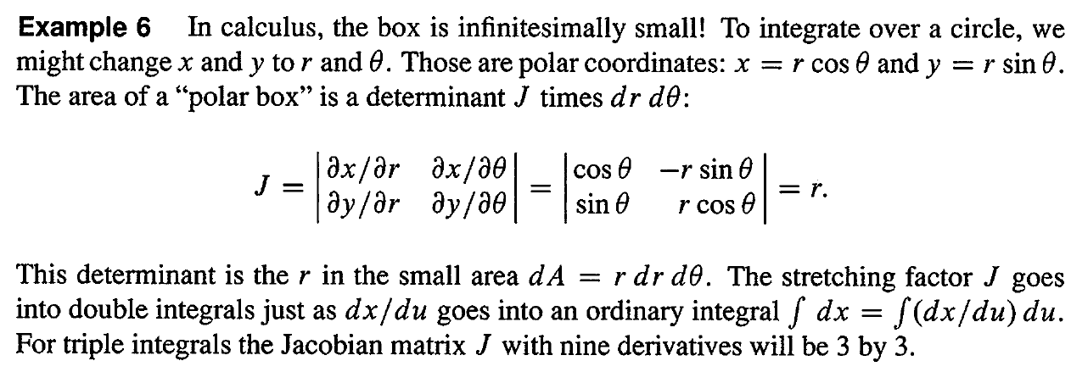

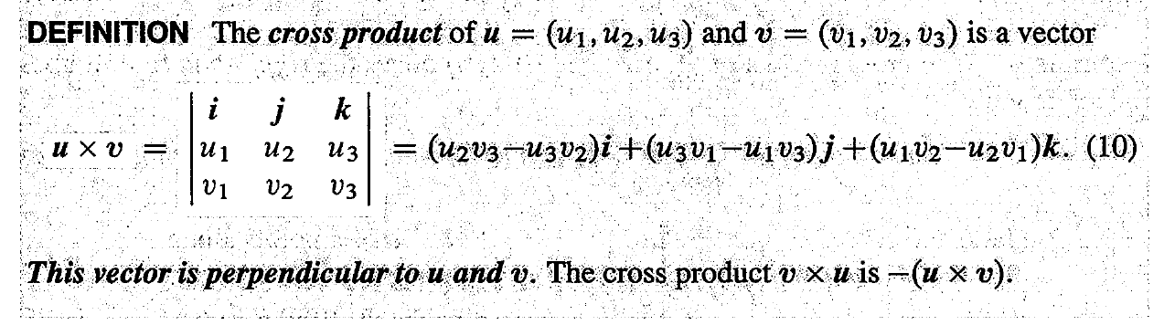

Property 1 $ν × μ$ reserves rows 2 and 3 in the determinant so it equals - $μ × ν$

Property 2 The cross product $μ × ν$ is perpendicular to $μ$ or $ν$. The direct proof is to watch terms cancel. Perpendicularity is a zero dot product.

Property: the cross product of any vector with itself (two equal rows) is 0.

$$μ × ν=\left||μ|\right|×\left||ν|\right|×sin⁡θ$$

The cross product is a vector with length $\left||μ|\right|×\left||ν|\right|×sin⁡θ$. Its direction is perpendicular to $μ$ and $ν$. It points “up” or “down” by the right hand rule.

The length of $μ × ν$ equals the area of the parallelogram with sides $μ$ and $ν$

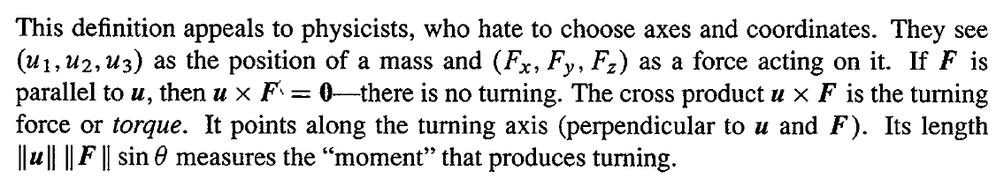

Triple product $(μ × ν)∙w$ = determinant = volume of the $μ, ν, w$ box.

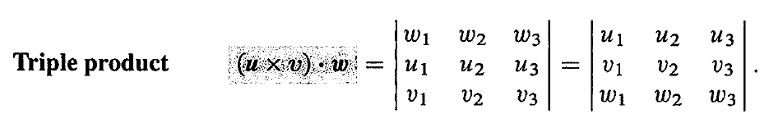

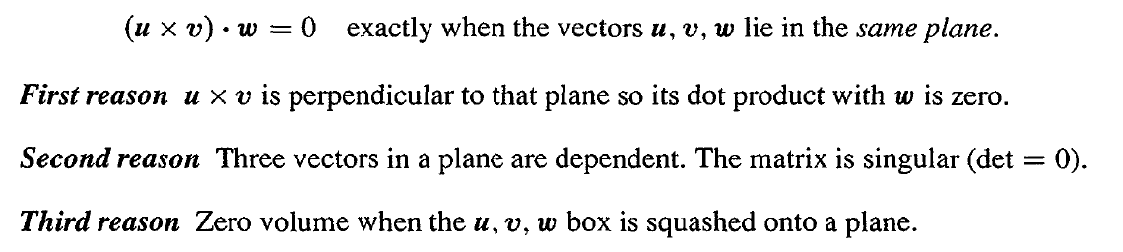

Chapter 6

Eigenvalues and Eigenvectors

This chapter enters a new part of linear algebra, based on Ax = λx. The number λ is an eigenvalue of A. All matrices in this chapter are square.

Almost all vectors change direction, when they are multiplied by A. certain exceptional vectors x are in the same direction as Ax. Those are the “eigenvectors”.

The eigenvalue λ tells whether the special vector is stretched or shrunk or reversed or left unchanged – when it is multiplied by A.

If A is the identity matrix, every vector has Ax = x. all vectors are eigenvectors of I. all eigenvalues “lambda” are λ = 1.

Most 2 by 2 matrices have two eigenvector directions and two eigenvalues.

How to compute the x’s and λ’s?

When A is squared, the eigenvectors stay the same. The eigenvalues are squared.

The eigenvector x1 is a steady state that does not change (because λ1 = 1). The eigenvector x2 is a “decaying mode” that virtually disappears (because λ2 = 1/2). The higher the power of A, the closer its columns approach the steady state.

In the **Markov matrix**, its entries are positive and every column adds to 1. Those facts guarantee that the largest eigenvalue is λ = 1.

The projection matrix P = $\left[\begin{matrix}0.5 & 0.5 \\ 0.5 & 0.5\end{matrix}\right]$ has eigenvalues λ = 1 and λ = 0.

Markov matrices and singular matrices and (most important) symmetric matrices have special λ’s and x’s:

Each column of P adds to 1, so λ = 1 is an eigenvalue.

P is singular, so λ = 0 is an eigenvalue.

P is symmetric, so its eigenvectors (1,1) and (1,-1) are perpendicular. Because the eigenvectors for λ = 0 fill up the null space. The eigenvectors for λ = 1 fill up the column space. The null space is projected to zero. The column space projects onto itself. The projection keeps the column space and destroys the nullspace.

Special properties of a matrix lead to special eigenvalues and eigenvectors.

* Projections have λ = 0 and 1.
* Permutations have all |λ| = 1.
* Reflections (R = $\left[\begin{matrix}1 & 0 \\ 0 & 1\end{matrix}\right]$, R = 2P - I) have λ = 1 and -1.

Insert page 286

## When the matrix is doubled, the eigenvalues are doubled; when a matrix is shifted by I, each λ is shifted by 1.

## For projections and reflections we found λ’s and x’s by geometry: Px = x, Px = 0, Rx = -x. Now we use determinants and linear algebra.

## The nonlinear equation: Ax = λx

## (A - λI)x = 0, that means that the eigenvectors make up the nullspace of A - λI. after obtaining the eigenvalue λ, we find the eigenvector. Eigenvalues first.

## How?

## If (A - λI)x = 0 has a nonzero solution, A - λI is not invertible. The determinant of A - λI must be zero.

## Eigenvalues The number λ is an eigenvalue of A iff A - λI is singular: det (A - λI) = 0.

When A is n by n, the equation has degree n. Then A has n eigenvalues and each λ leads to x.

There is a whole line of eigenvectors – any nonzero multiple of x is as good as x. MATLAB’s eig(A) divides by the length, to make the eigenvector into a unit vector.

Note: sometimes some n by n matrices do not have n independent eigenvectors. Without n eigenvectors, we do not have a basis. We can not write every v as a combination of eigenvectors. In the language of the next section, we can not diagonalize a matrix without n independent eigenvectors.

Eigenvalues change when the row switches.

The product of the n eigenvalues equals the determinant.

The sum of the n eigenvalues equals the sum of the n diagonal entries.

The sum of the entries on the main diagonal is called the trace of A

Question: why do the eigenvalues of a triangular matrix lie on its diagonal?

Imaginary eigenvalues

The 90 degree rotation Q = $\left[\begin{matrix}0 & -1 \\ 1 & 0\end{matrix}\right]$ has no real eigenvectors. Its eigenvalues are λ = I and λ = -i. sum of λ’s = trace = 0. Product = determinant = 1.

Q is an orthogonal matrix so the absolute value of each λ is |λ| = 1.

Q is a skew-symmetric matrix so each λ is pure imaginary.

A symmetric matrix (AT = A) can be compared to a real number. A skew-symmetric matrix (AT = -A) can be compared to an imaginary number. An orthogonal matrix (ATA = I) can be compared to a complex number with |λ| = 1.

Review of the key ideas

* Ax = λx says that eigenvectors x keep the same direction when multiplied by A.
* It also says that det(A-λI) = 0. This determines n eigenvalues.
* The eigenvalues of A2 and A-1 are λ2 and λ-1, with the same eigenvectors.

Triangular matrices have λ’s on their diagonal.

Diagonalizing a Matrix

A diagonal matrix is a matrix in which the entries outside the main diagonal are all zero. The diagonal entries themselves may or may not be zero.

The operations of matrix addition and [matrix multiplication](http://en.wikipedia.org/wiki/Matrix_multiplication) are especially simple for diagonal matrices. Write diag(*a*1,...,*an*) for a diagonal matrix whose diagonal entries starting in the upper left corner are*a*1,...,*an*. Then, for addition, we have

diag(*a*1,...,*an*) + diag(*b*1,...,*bn*) = diag(*a*1+*b*1,...,*an*+*bn*)

and for [matrix multiplication](http://en.wikipedia.org/wiki/Matrix_multiplication),

diag(*a*1,...,*an*) · diag(*b*1,...,*bn*) = diag(*a*1*b*1,...,*anbn*).

The diagonal matrix diag(*a*1,...,*an*) is [invertible](http://en.wikipedia.org/wiki/Invertible_matrix) [if and only if](http://en.wikipedia.org/wiki/If_and_only_if) the entries *a*1,...,*an* are all non-zero. In this case, we have

diag(*a*1,...,*an*)-1 = diag(*a*1-1,...,*an*-1).

When x is an eigenvector, multiplication by A is just multiplication by a single number. All the difficulties of matrices are swept away. Now we can follow the eigenvectors separately.

The matrix A turns into a diagonal matrix Λ (capital lamda) when we use the eigenvectors properly.

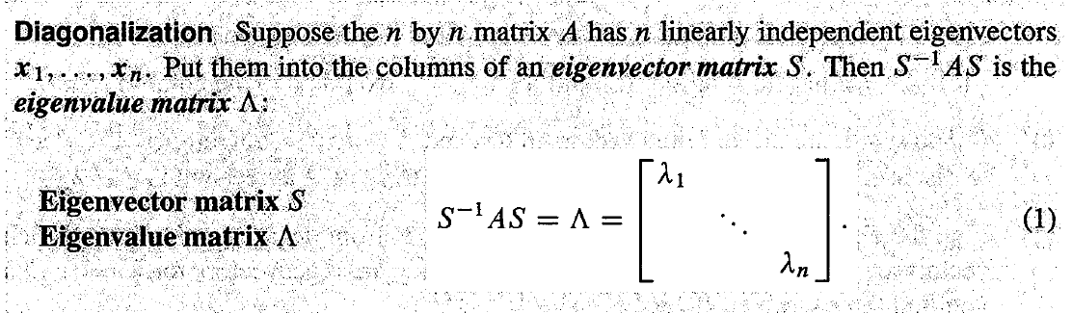

(note: without n independent eigenvectors (an eigenvector matrix S), we can not diagonalize)

Me: When A is n by n, the equation has degree n. Then A has n eigenvalues and each λ leads to x. Under what conditions the n linearly independent eigenvectors are independent? Only these eigenvectors are independent, S-1 exists.

A: if λ1, λ2, …, λn are all different, then the eigenvectors are independent.

Extreme case is A = I, when every vector is an eigenvector. Any invertible matrix S can be the eigenvector matrix.

Proof: AS = SΛ

table

|  |  |  |
| --- | --- | --- |
|  | A | Λ |
| Eigenvalues | λ1, λ2, …, λn | λ1, λ2, …, λn |
| Eigenvectors | Columns of S | Columns of I |
|  |  |  |

By diagonalizing A and reaching Λ, we can solve differential equations or difference equations or even Ax = b.

The relationship between invertibility and diagonalizability?

No connection. Invertibility is concerned with the eigenvalues (zero or not). Diagonalizability is concerned with the eigenvectors (too few or enough).

$$S^{-1}AS= Λ$$

$$A= SΛS^{-1}$$

$$A^{n}=SΛ^{n}S^{-1}$$

(Note: perfect for matrix powers and differential equations)

Eigenvalues of AB and A + B are not λβ or λ + β.

The reason is that A and B generaly do not share the same eigenvector x.

If AB = BA, then A and B share the same eigenvector matrix S.

Suppose λ is an eigenvalue of A. We discover that fact in two ways:

1. Eigenvectors (geometric) there are nonzero solutions to Ax = λx.
2. Eigenvalues (algebraic) the determinant of A - λI is zero.

The multiplicity of the number λ

1. Geometric Multiplicity count the independent eigenvectors for λ. This is the dimension of the nullspace of A-λI.
2. Algebraic Multiplicity count the repetitions of among the eigenvalues. Look at the n roots of det(A-λI) = 0.

The eigenvalues of A-1 are 1/λ

Applications to diferential equations

The point of the section is this: To convert differential equations into linear algebra.

$$\frac{du}{dt}=λu has the solutions u\left(t\right)=Ce^{λt}$$

where C is determined from the initial condition.

In linear algebra

$$\frac{du}{dt}=Au$$

Where u(0) is known at t = 0.

Here, A is a constant matrix, not a function of t or of u.

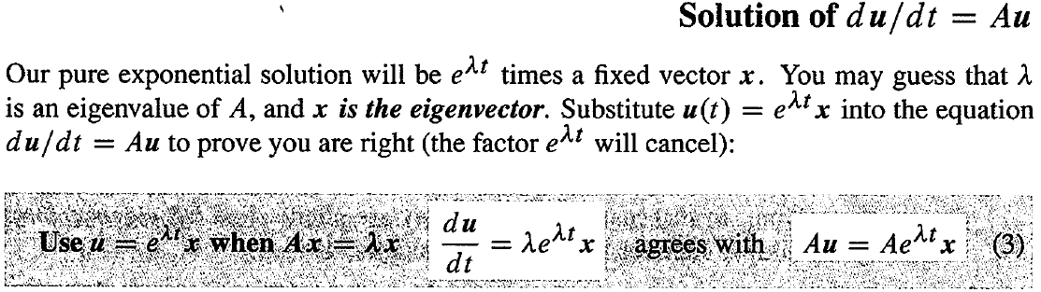

Stability of 2 by 2 matrices

Question: does the solution approach u = 0 as t 🡪 infinity?

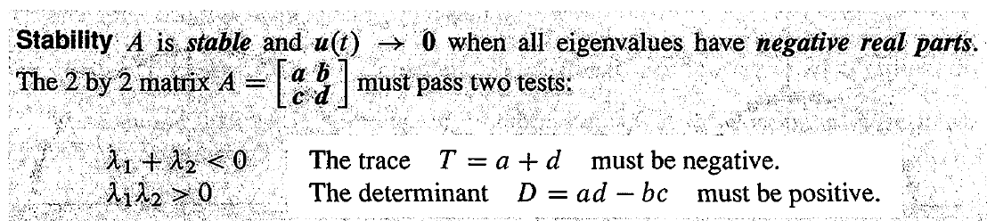

$$e^{At}=Se^{Λt}S^{-1}$$

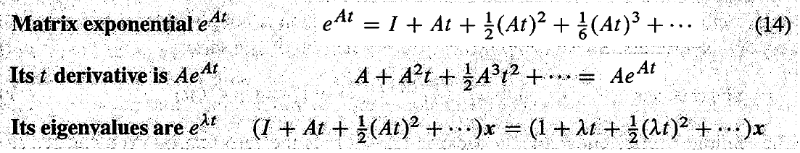

The eigenvalues of eAT are eλT

When A is skew-symmetric (AT = -A), eAT is orthogonal.

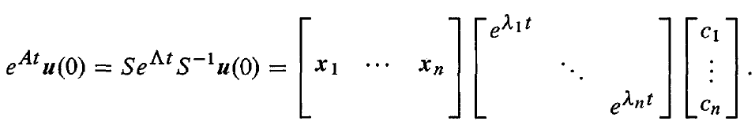

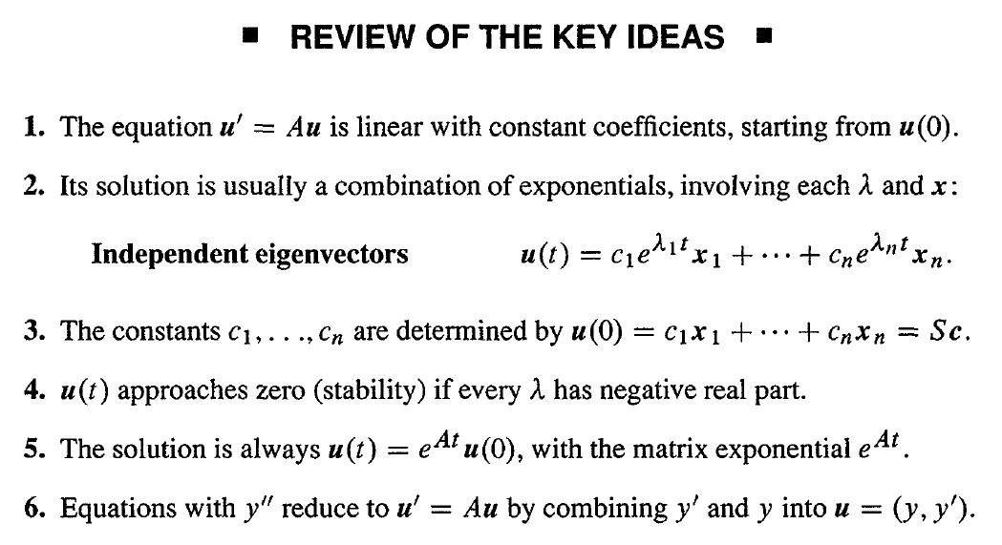

Symmetric matrices

The goal is to diagonalize symmetric matrices A by orthogonal eigenvector matrices.

What is special about Ax = λx when A is symmetric? We are looking for special properties of the eigenvalues λ and the eigenvectors x when A = AT.

A symmetric matrix has only real eigenvalues.

The eigenvectors can be chosen orthonormal.

Every symmetric matrix has the factorization A = QΛQT with real eigenvalues in Λ and orthonormal eigenvectors in Q:

A = QΛQ-1 = QΛQT

The eigenvalues of a real symmetric matrix are real

Eigenvectors of a real symmetric matrix are always perpendicular.

* Pivots come from elimination.
* Eigenvalues come from determinants.

So, the connection between them is:

Product of pivots = determinant = product of eigenvalues.

All symmetric matrices are diagonalizable.

The spectral theorem for symmetric matrices says that A is a combination of projection matrices

A real matrix has perpendicular eigenvectors iff ATA = AAT. symmetric and skew-symmetric and orthogonal matrices are included among these normal matrices.

Positive definite matrices (symmetric matrices that have positive eigenvalues)

Calculating eigenvalues is work. But if we just want to know that they are positive, there are faster ways. So in this section, the goal is to find quick tests on a symmetric matrix that guarantee positive eigenvalues; to explain two applications of positive definiteness.

Positive eigenvalues mean positive pivots and vice versa.

It is very satisfying to see pivots and determinants and eigenvalues come together.

The eigenvalues of A=AT are positive iff the pivots are positive:

a>0 and (ac-b2)/a > 0

in calculus, if f’’ is positive and a > 0, the curve bends up from its tangent line.

The function f = xTAx has a minimum at x=y=0 iff A is positive definite, which is the 2 by 2 version of a is “a” positive number.



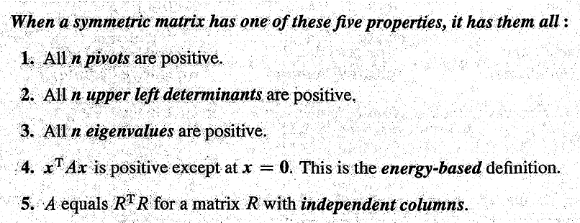

Application: #1, minimum

When the first derivatives are zero and the second derivative matrix is positive definite, we have found a local minimum.

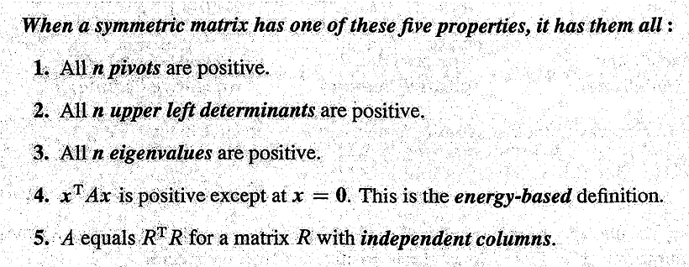

Application: #2, minimum

S: the eigenvector matrix;

M: the invertible matrix;

Λ: the eigenvalue matrix;

Similar matrices: B = M-1AM is similar to A.

Idea: to make A as simple as possible while preserving its essential properties.

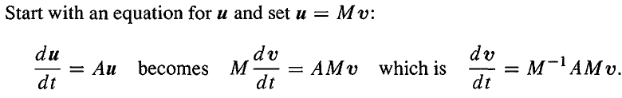

Similar matrices A and M-1AM have the same eigenvalues. If x is an eigenvector of A then M-1x is an eigenvector of B = M-1AM

How to approach to similar matrices?

Change the variables

Change the basis

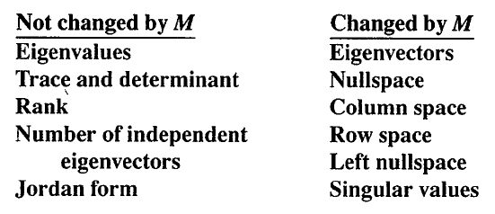

Singular value decomposition (SVD)

Data compression (replace m by n entries by a smaller number, in a way that the human visual system won’t notice)

Methods:

Fourier transforms (used in jpeg)

Wavelets (used in JPEG2000)

SVD: replace the 256 by 512 pixel matrix by a matrix of rank one: a column times a row.

What are we asking for:

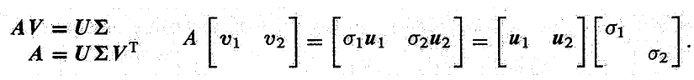

Where v1 and v2 are orthonormal.

A = UΣV-1 = UΣVT = orthogonal x diagonal x orthogonal.

where U and V are orthogonal, VTV = I

Q: how to find v?

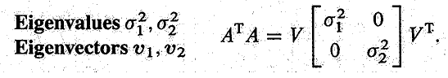

The eigenvectors of the symmetric matrix (ATA) are perpendicular.

Q: how to find u?

Av = σu

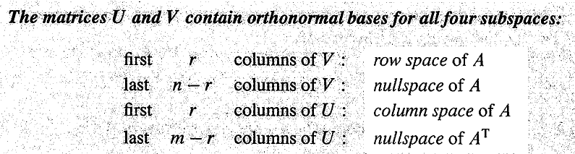

Linear Transformation

In goes v, outcomes Av. This transformation follows the same idea as a function.



Rotaion is linear.

Transformation language:

range of T: column space

kernel of T: nullspace

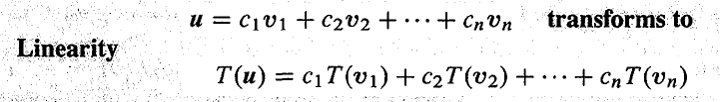

Q: how to represent any linear transformation by a matrix A?

If you integrate a function and then differentiate, you get back to the start. AA-1 = I

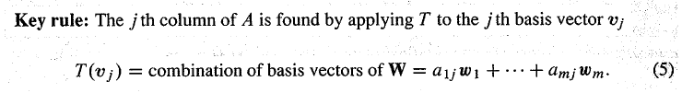

Every linear transformation (T) can be converted to a matrix (A). This matrix depends on the bases. If the bases change, T is the same but the matrix A is different.

Steps:

Find vi, wi,

Find Wi after T(v)

Then use Wi

Points:

Linear transformations T are everywhere – in calculus and differential equations and linear algebra;

Spaces other than Rn are important – we had functions, cubics, and quadratics;

T still boils down to a matrix.

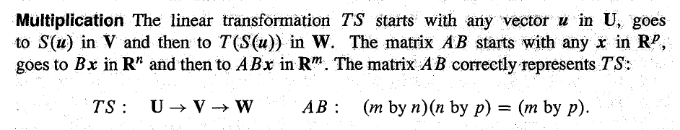

The whole idea of a transform is exactly a change of basis.

Remember what it means for the vectors wi to be a basis for Rm:

a. the w’s are linearly independent;

b. the n x n matrix W with these columns is invertible.

c. every vector v in Rn can be written in exactly one way as a combination of the w’s:

v = ciwi

why do we want to change the basis?

In image processing and audio coding, you can’t see or hear the difference. We do not need the other 95%.

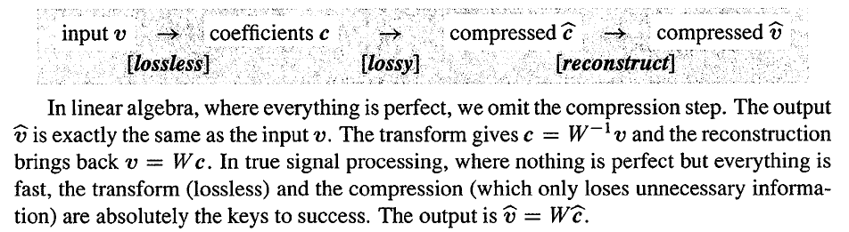

Wavelet basis

The first thing an electrical engineer does with a signal is to take its Fourier Transform (F), which is the most important complex matrix in math and science and engineering.

By choosing a better basis than the standard basis, we may produce a better matrix than A.

Most of this book is focused on one fundamental question: to make the matrix simple.

In chapter 2 we made it triangular by elimination;

In chapter 4 we made it triangular by Gram-Schmidt;

In chapter 6 we made it diagonal by eigenvectors;

In chapter 7 we made it from A to Λ by changes of a basis;

SVD chooses orthonormal bases that diagonalize A.

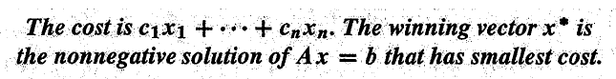

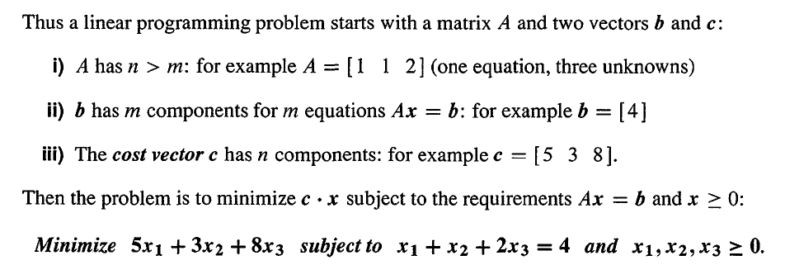

The fourier coefficient:

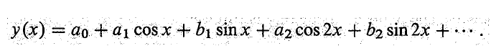

Use orthogonality, the coefficient is found by



It is easier to find coefficients when the basis vectors are orthonormal.

